2024-01-27 - Handout – Backtracking

# Q1. All paths from source to target

Link<:> <https://leetcode.com/problems/all-paths-from-source-to-target/>

Given a directed acyclic graph (**DAG**) of n nodes labeled from 0 to n – 1, find all possible paths from node 0 to node n – 1 and return them in **any order**.

The graph is given as follows: graph[i] is a list of all nodes you can visit from node I (i.e., there is a directed edge from node I to node graph[i][j]).

**Example 1:**

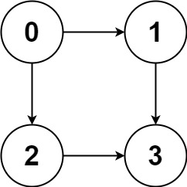

**Input:** graph = [[1,2],[3],[3],[]]

**Output:** [[0,1,3],[0,2,3]]

**Explanation:** There are two paths:

0 -> 1 -> 3 and 0 -> 2 -> 3.

**Example 2:**

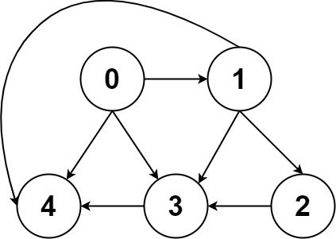

**Input:** graph = [[4,3,1],[3,2,4],[3],[4],[]]

**Output:** [[0,4],[0,3,4],[0,1,3,4],[0,1,2,3,4],[0,1,4]]

**Constraints:**

* n == graph.length
* 2 <= n <= 15
* 0 <= graph[i][j] < n
* graph[i][j] != I (i.e., there will be no self-loops).
* All the elements of graph[i] are **unique**.
* The input graph is **guaranteed** to be a **DAG**.

# Q2. Word Break II

Link: <https://leetcode.com/problems/word-break-ii>

Given a string s and a dictionary of strings wordDict, add spaces in s to construct a sentence where each word is a valid dictionary word. Return all such possible sentences in **any order**.

**Note** that the same word in the dictionary may be reused multiple times in the segmentation.

**Constraints:**

* 1 <= s.length <= 20
* 1 <= wordDict.length <= 1000
* 1 <= wordDict[i].length <= 10
* s and wordDict[i] consist of only lowercase English letters.
* All the strings of wordDict are **unique**.
* Input is generated in a way that the length of the answer doesn't exceed 105.